Developing Health Knowledge
Activity or Task: ______________________________________ Content area: _____________________
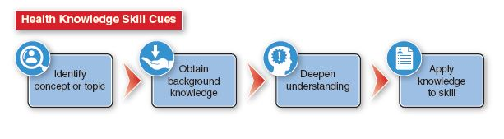
 | Above Mastery  4 | Mastery  3 | Approaching Mastery  2 | Novice  1
Identify Concept or Topic | Concept or topic is specific and clearly identified. | Concept or topic is broad and clearly identified. | Concept or topic is vague. | Concept or topic cannot be identified.
Obtain Background Knowledge | Background knowledge obtained of the concept or topic is of excellent quality and quantity and is relevant and accurate to the task. | Background knowledge obtained of the concept or topic is of appropriate, relevant, and accurate quality and quantity to the task. | Background knowledge obtained of the concept or topic is appropriate to the task but limited in quality and quantity | Background knowledge obtained of the concept or topic is inappropriate to the task.
Deepen Understanding | Understanding of the identified concept or topic is significantly deepened. | Understanding of the identified concept or topic is deepened. | Understanding of the identified concept or topic is limited. | Understanding of the identified concept or topic is inaccurate.
Apply Knowledge to Skill | Applies identified concept or topic knowledge to at least two or more health skills. | Applies identified concept or topic knowledge to at least one health skill. | Struggles to apply identified concept or topic knowledge to a health skill. | Unable to accurately apply concept or topic knowledge to a health skill.
Score: _______________
Comments:

Analyzing Influences
Activity or Task:________________________________________________________________
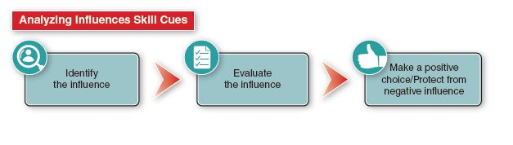
 | Above Mastery  4 | Mastery  3 | Approaching Mastery  2 | Novice  1
Identify the Internal and External Influences | Accurately identifies two internal AND two external influences. | Accurately identifies one internal AND one external influence. | Accurately identifies at least one internal influence OR one external influence. Does not accurately identify both. | Unable to correctly identify internal or external influences.
Evaluate the Internal and External Influences | Accurately and completely explains how two internal influences could impact them AND explains how two external influences could impact them. | Effectively explains how one internal influence could impact them AND how one external influence could impact them. | Effectively explains how one internal influence OR one external influence could impact them. | Unable to accurately explain how either an internal or external influence could impact them.
Make a Positive Choice/Protect from Negative Influence | Able to fully explain two positive choices they could make from the internal and/or external influences identified AND how they could protect themself from two possible negative influences. | Able to explain one positive choice they could make from the internal and/or external influences identified AND how they could protect themself from a negative influence. | Able to give an example or explain one positive choice they could make from the internal and/or external influences identified OR can give an example or explain one way they could protect themself from a negative influence. | Unable to give an appropriate example of a positive choice they could make from an internal and/or external influence OR give an appropriate example of a way they could protect themself from an internal and/or external negative influence.
Score: _______________
Comments:

Accessing Valid and Reliable Information
Activity or Task: _______________________________________________________________
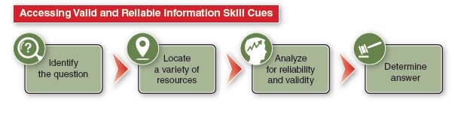
 | Above Mastery  4 | Mastery  3 | Approaching Mastery  2 | Novice  1
Identify the Question | Question or issue is accurately AND appropriately identified. | Question or issue is accurately OR appropriately identified. | Question or issue is not clearly identified. | Question or issue is not accurately identified.
Locate a Variety of Resources | A variety of different resources are used and are of high quality and appropriateness for the question or issue. | A variety of similar resources are used and are of satisfactory quality and appropriateness for the question or issue. | Resources are limited and quality and appropriateness are marginal for the question or issue. | Resources are not of quality and/or are not appropriate.
Analyze for Reliability and Validity | All information was appropriately analyzed for reliability and validity. | Majority of information was appropriately analyzed for reliability and validity. | Information was inconsistently analyzed for reliability and/or validity and/or errors are found. | Information is not analyzed for reliability or validity or errors are found.
Determine Answer | Question or issue is thoroughly addressed. | Question or issue is satisfactorily addressed. | Question or issue is not completely addressed. | Question or issue is not accurately addressed.
Score: _______________
Comments:

Accessing Valid and Reliable Web Information
Activity or Task: _______________________________________________________________________
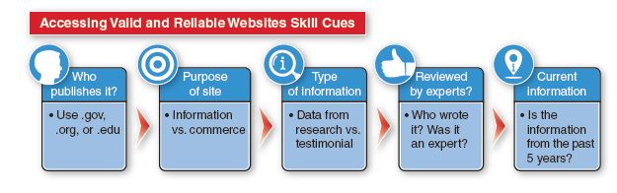
 | Above Mastery  4 | Mastery  3 | Approaching Mastery  2 | Novice  1
Who Publishes It: Use .gov, .org or .edu | All sites used were .gov, .org, or .edu. | Over half the sites used were .gov, .org, or .edu. | Half or less than half the sites used were .gov, .org, or .edu. | None of the sites used were .gov, .org, or .edu.
Purpose of Site: Information vs commerce | All sites used were information-based sites rather than commerce based. | Over half the sites used were information-based sites rather than commerce based. | Half or less than half the sites used were information-based sites, most were commerce based. | None of the sites used were information-based sites, they were all commerce based.
Type of Information: Data from research vs testimonial | All information gathered was research based rather than testimonial. | Over half the information gathered was research based rather than testimonial. | Half or less than half the information gathered was research based, most was testimonial. | None of the information gathered was research based, all was testimonial.
Reviewed by Experts: Who wrote it? Are they an expert? | All information was written or reviewed by a content expert. | Over half the information was written or reviewed by a content expert. | Half or less than half the information was written or reviewed by a content expert. | None of the information was written or reviewed by a content expert.
Current Information: Was the information written within the last 5 years? | All information was written within the last 5 years. | Over half the information was written within the last 5 years. | Half or less than half the information was written within the last 5 years. | None of the information was written within the last 5 years.
Score: _______________
Comments:

Healthy Communication
Activity or Task: _______________________________________________________________________
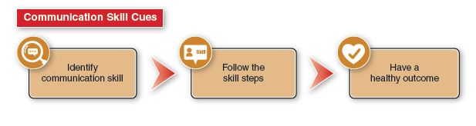
 | Above Mastery  4 | Mastery  3 | Approaching Mastery  2 | Novice  1
Identify Communication Skill | Correctly identifies the appropriate communication skill needed – refusal skills, active listening, conflict resolution, assertiveness, negotiation, I-messages – and explains why it is the correct skill. | Correctly identifies the appropriate communication skill needed – e.g. refusal skills, active listening, conflict resolution, assertiveness, negotiation, I-messages | Correctly identifies – refusal skills, active listening, conflict resolution, assertiveness, negotiation, I-messages - as an appropriate communication skill but does not choose the correct skill for the situation. | Does not correctly identify – refusal skills, active listening, conflict resolution, assertiveness, negotiation, I-messages – as a communication skill.
Follow the Skill Steps | Follows all the skill steps appropriately. | Follows over half the skill steps appropriately. | Follows half or less than half the skill steps appropriately. | Does not follow the skills steps appropriately.
Have a Healthy Outcome | Effective use of the correct communication skill AND skill steps in order results in a healthy outcome. | Effective use of the correct communication skill results in a healthy outcome. | Proper use of an incorrect communication skill results in an outcome not as healthy as it could be. | Incorrect use of an incorrect communication skill results in an unhealthy outcome.
Score: _______________
Comments:

Making Health Decisions
Activity or Task: _______________________________________________________________________
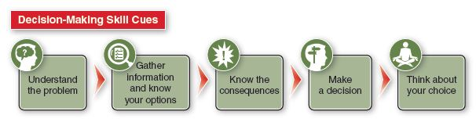
 | Above Mastery  4 | Mastery  3 | Approaching Mastery  2 | Novice  1
Understand the Problem | Problem is clearly stated and clearly understood. | Problem is correctly identified but understanding is superficial. | Problem is correctly identified. | Problem is not correctly identified.
Gather Information and Know Your Options | Information is accurate and there is an adequate amount of information to identify appropriate options. | Information was accurate but there was limited information gathered AND options identified are superficial. | Information gathered was vague and limited and/or options identified are superficial. | Information was not accurate and/or options were not identified.
Know the Consequences | Consequences are identified and are comprehensive and explained. | Consequences are clearly identified but may or may not be well explained. | Consequences are identified but are vague. | Consequences are not correctly identified.
Make a Decision | Healthy decision is made clearly using the information, options, and consequences identified. | Healthy decision is made but it is vague as to the specific information, options, and/or consequences that were used. | Healthy decision is made yet it is unclear how the decision was made. | Healthy decision is not made and/or the steps of the decision-making process are not evident OR an unhealthy decision is made.
Think About Your Choice | Student can think about the choice they made and see other possible options AND consequences. | Student can think about the choice they made and see other possible options OR consequences. | Student can think about the choice they made and know there are other possibilities but struggles to identify other possible options OR consequences without assistance. | Student is unwilling to see other appropriate options or consequences.
Score: _______________ (continued on next page)

Making Health Decisions (continued)

Comments:

Goal Setting
Activity or Task: ______________________________________ Content area: _____________________
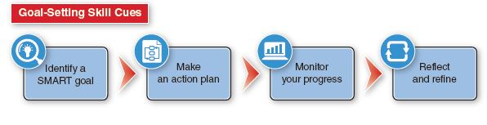
 | Above Mastery  4 | Mastery  3 | Approaching Mastery  2 | Novice  1
Identify a SMART Goal:  Specific to student actions.  Measurable to determine progress.  Achievable for the student.  Realistic and makes sense to the student.  Timely for the student. | All elements of the SMART skill cue are present and written to show details of each element. | All elements of the SMART skill cue are present but one of the elements is lacking in detail and/or is unclear. | One element of the SMART skill cue is missing OR two or more of the elements are lacking in detail and/or is unclear. | Two or more elements of the SMART skill cue are missing OR the goal is not written using the SMART skill cues.
Make an Action Plan | The action plan includes at least two specific steps you can do that will help you achieve your SMART goal. | The action plan includes one specific step you can do that will help you achieve your SMART goal. | The action plan includes vague steps you may or may not be able to do and that may or may not help you achieve your SMART goal. | The action plan does not include steps you can do that would help you achieve your SMART goal.
Monitor Your Progress | Student keeps a detailed weekly log of their SMART goal progress. | Student keeps an accurate weekly log of their SMART goal progress, but it lacks detail. | Student keeps a vague weekly log of their SMART goal progress; some entries may be missing. | Student has been inconsistent in keeping their weekly log for their SMART goal.

(continued on next page)

Goal Setting (continued)

 | Above Mastery  4 | Mastery  3 | Approaching Mastery  2 | Novice  1
Reflect and Refine | Student can reflect on their SMART goal and can refine at least two elements to be more descriptive or detailed. | Student can reflect on their SMART goal and can refine one element to be more descriptive or detailed. | Student can reflect on their SMART goal and knows changes could be made but struggles to find a way to refine any of the elements to make them more descriptive or detailed without assistance. | Student is unwilling to see changes that could be made.

Score: _______________
Comments:

Practicing Healthy Behaviors
Activity or Task: ______________________________________ Content area: _____________________
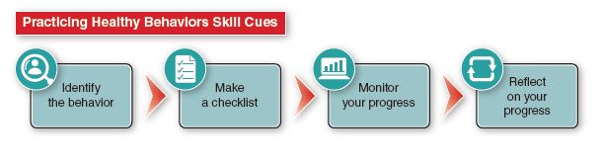
 | Above Mastery  4 |  | Mastery  3 |  | Approaching Mastery  2 |  | Novice  1
Identify the Behavior | Student clearly and thoughtfully identifies an appropriate healthy behavior AND can explain a healthy benefit that can be gained. | Student can clearly identify an appropriate healthy behavior AND can list a benefit that can be gained. |  | Student can identify an appropriate healthy behavior. |  | Student does not identify a healthy behavior.
Make a Checklist | Student makes or locates an accurate and usable checklist to monitor their healthy behavior. | Student makes or locates a usable checklist to monitor their healthy behavior. |  | Student makes or locates a checklist that does not align properly with their healthy behavior. |  | Student’s checklist is not usable for their behavior.
Monitor Your Progress | Student regularly and thoroughly monitors progress using the checklist. | Student regularly monitors progress but uses checklist inconsistently. |  | Student inconsistently monitors progress and may or may not use the checklist. |  | Student rarely monitors progress.
Reflect on Your Progress | Student thoughtfully reflects on progress based on the consistent use of their checklist. | Student can reflect on their progress as they do monitor it, but it is unclear as to how much progress they may have made due to the inconsistent us of their checklist. |  | Student cannot reflect accurately on their progress due to a poorly aligned checklist and inconsistent monitoring. |  | Student is unable to reflect on their progress as they do not have an appropriate checklist and they rarely monitor their progress.
Score: _______________
Comments:

Advocating for Good Health
Activity or Task: _______________________________________________________________________
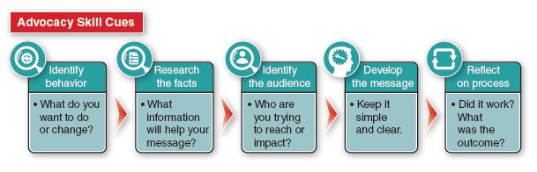
 | Above Mastery  4 | Mastery  3 | Approaching Mastery  2 | Novice  1
Identify Behavior or Issue | Identifies a specific behavior or issue AND can explain why change is necessary. | Identifies a general behavior or issue and can list reasons change is needed. | Identifies a general behavior or issue to change. | Unable to correctly identify a behavior or issue to change.
Research the Facts | Researches facts essential to the specific behavior or issue. | Researches facts AND general information specific to the behavior or issue. | Primarily uses general information with a few facts specific to the behavior or issue. | Chooses facts and/or information not relevant to the behavior or issue.
Identify the Audience | Clearly identifies an appropriate target audience AND can explain why they were chosen specific to the behavior or issue. | Clearly identifies an appropriate target audience AND can list reasons they were chosen specific to the behavior or issue. | Identifies a target audience in which some may or may not be the correct people specific to the behavior or issue. | Identifies a target audience in which most of the people are not the correct people specific to the behavior or issue.
Develop the Message | Develops a clear and simple message precisely aligned to the specific behavior or issue. | Develops a clear and simple message closely aligned to the specific behavior or issue. | Develops a clear and/or simple message loosely aligned to the specific behavior or issue. | Message is unclear and/or is not aligned to the specific behavior or issue.

(continued on next page)

Advocating for Good Health (continued)

 | Above Mastery  4 | Mastery  3 | Approaching Mastery  2 | Novice  1
Reflect on Process | Student reflects on the process and outcome of the advocacy and can identify concepts to change AND to keep the same if they were to advocate again. | Student reflects on the process and outcome of the advocacy and can identify concepts to change OR concepts to keep the same if they were to advocate again. | Student can reflect on the process OR the outcome of the advocacy. | Student is unwilling to reflect on the process OR the outcome of the advocacy.
Score: _______________
Comments:

