Skill-Building Challenge Worksheet: Self-Esteem and Decision Making
Name: Blank Class: Blank Date: Blank
Pair up into partners or get into groups according to your teacher’s instructions. Read the start of the following story. Finish the story first by assuming that Amir struggled with low self-esteem. Then finish the story again assuming Amir had good self-esteem. As you write the ending of each story, think about how self-esteem could influence his decisions. Use the Decision-Making Skill Cues to remind you about what decision-making steps should be in the story.
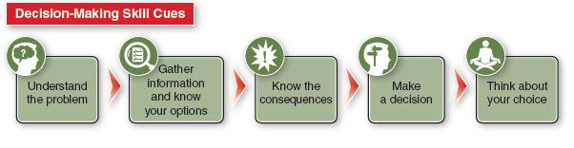
AMIR'S DECISION
Amir was hanging out with friends after school. His friend Wyatt wanted to skip school the next day and go hang out by the river. Aiden thought he might be able to sneak some food out of his house after his mom left for work and David thought he could bring an inner tube for floating. Amir felt anxious about the situation. He has a test in English class tomorrow, and he knows his friends sometimes do stupid things.
- How does this story end if Amir has low self-esteem?

How does this story end if Amir has high self-esteem?

