Skill-Building Challenge Worksheet: Making Healthy Decisions

Name: Blank Class: Blank Date: Blank
Step 1: Understand the Problem
Making healthy decisions will affect all parts of your life, including your mental well-being. Use a decision tree described in the following paragraph to map the choices you have when you are dealing with a situation that could, or does, make you feel sad. Think of a situation you are in or have been in. If you are struggling to identify your own situation, use the story of Anton from this chapter for your tree.
Sad situation:

Step 2: Gather Information, Know Your Options, and Know the Consequences
A decision tree is a way to visually show the options you have when making a decision. It can help you move through all the important steps that are part of the Decision-Making Skill Cues. Here is an example of a decision tree.
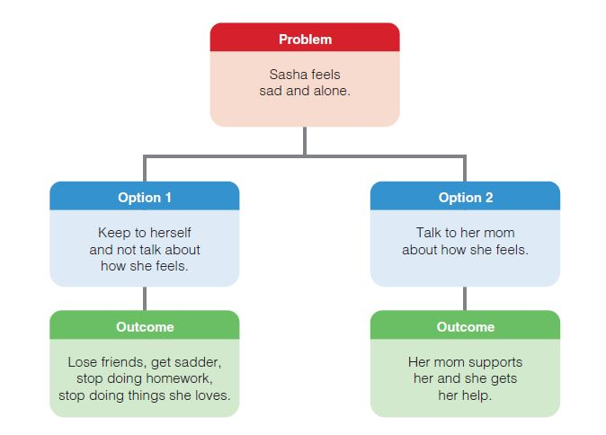(continued on next page)
Complete the decision tree below for your sad situation.

Step 3: Make the Decision and Think About Your Choice
Once you have completed your tree, decide which decision you think has the best outcome, and explain your decision.

