Skill-Building Challenge Worksheet: Making Healthy Decisions

Name: Blank Class: Blank Date: Blank
Read through each scenario below and use the decision-making process to decide what the person should do. After you have made your decisions, identify one short-term and one long-term consequence of the decision.
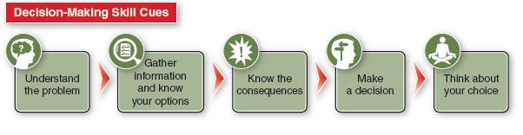
SCENARIO 1: COLBY AND COLIN Colby and Colin are brothers. Colby is three years older than Colin. Both boys are athletes and Colin is also a musician. Colin practices guitar with some of his friends in their family’s garage. Colby is tired of listening to what he calls the bad music, and he and his friends just want to play video games without all the background noise. Colby doesn’t want his friends to stop coming over because of his little brother. That night, Colby forced Colin’s hand into their bedroom door and slammed it shut. Colin couldn’t play guitar for a couple of weeks because of the injury. What should Colby do in this situation?
What is a potential short-term consequence of your decision? What is a potential long-term consequence of your decision?
SCENARIO 2: JADEN AND MORGAN Jaden and Morgan are friends and they have liked each other for a while. Jaden bought Morgan an expensive gift last week. Today Jaden said, “Come on Morgan, won’t you just kiss me? I bought you that expensive gift last week. I think you kind of owe me something.” What should Morgan do in this situation?
What is a potential short-term consequence of your decision? What is a potential long-term consequence of your decision?

