Skill-Building Challenge Worksheet: Analyzing Influences on Sun-Safety Practices

Name: Blank Class: Blank Date: Blank
Adam and Heath are spending the day at the beach with Adam’s family. It is somewhat overcast but the sun is starting to come out. Adam’s guardian reminds Adam and Heath to put sunscreen on. They both put on sunscreen and head into the water. They swim and mess around in the water for 30 minutes or so and then get out to lie in the sun. Adam asks Heath if he wants more sunscreen and he says no because he wants to work on his tan and a little bit of a burn will be alright. Adam decides not to put on any more sunscreen either. Heath tends to tan pretty easily and isn’t very worried about getting burned. Adam on the other hand hasn’t been out in the sun much yet this summer and will probably burn if he doesn’t continue to put on sunscreen. Adam’s guardian throws the bottle of sunscreen to Adam and tells him to put more on. Adam thinks putting on sunscreen will make him look kind of weak in front of Heath so he doesn’t put any more on. Adam also saw some information on the Internet the other day about people looking better the more tan they are, so his goal today is to get tan. Adam knows once the sunburn goes away he will be tan and look good. They spend the rest of the day going back and forth between the water and lying on the beach. Heath has gotten a little red but within a day or two he will tan. Adam has definitely gotten a sunburn and will even have a few spots that will blister.
Put yourself in Adam’s place about the people and concepts that influenced him, and using the Analyzing Influences Skill Cues on the next page, identify who or what the influences are, evaluate whether the influences are positive or negative, make a positive choice, and reflect on the benefits of your choice.
(continued on next page)

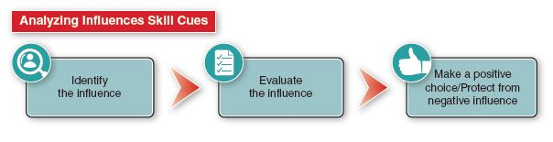
1. There were two people Adam could have been influenced by to use or not use sunscreen.
Who were the two people?

Which person influenced Adam?

What was the decision Adam made about using or not using sunscreen?

Why did Adam make the decision he did?

2. What happened to Adam based on the decision he made about the sunscreen?

3. Did Adam make a positive or negative choice? What was the consequence of Adam’s choice?

4. What do you think Heath would have thought if Adam had made the opposite choice?

